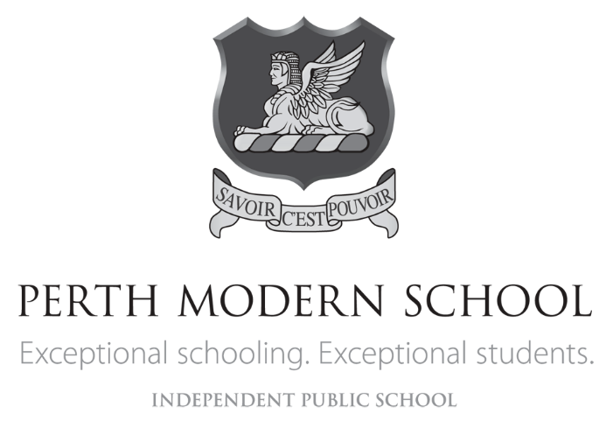

YEAR 12 CHEMISTRY TEST 4

Organic Chemistry Question/Answer Booklet

STUDENT NAME

TEACHER

Recommended time: 50 minutes

Materials provided for this test
- Test booklet
- Multiple-choice Answer sheet
- Chemistry Data Sheet

STRUCTURE OF THIS TEST
Section One: 15 Multiple- choice questions 15 marks
Section two: 6 Short answer questions 35 marks

Section One: Multiple-choice (15 Marks)

This section has 15 questions. Answer all questions on the separate Multiple-choice answer sheet provided. For each question, put a cross in the appropriate box to indicate your answer. Use only a blue or black pen to draw the cross. If you make a mistake, shade the box with the incorrect answer, then place a cross in the box with the new answer. Do not use correction fluid/tape. Marks will not be deducted for incorrect answers. No marks will be given if more than one answer is completed for any question.

Suggested working time: 15 minutes

1. Consider the section of the polymer below.
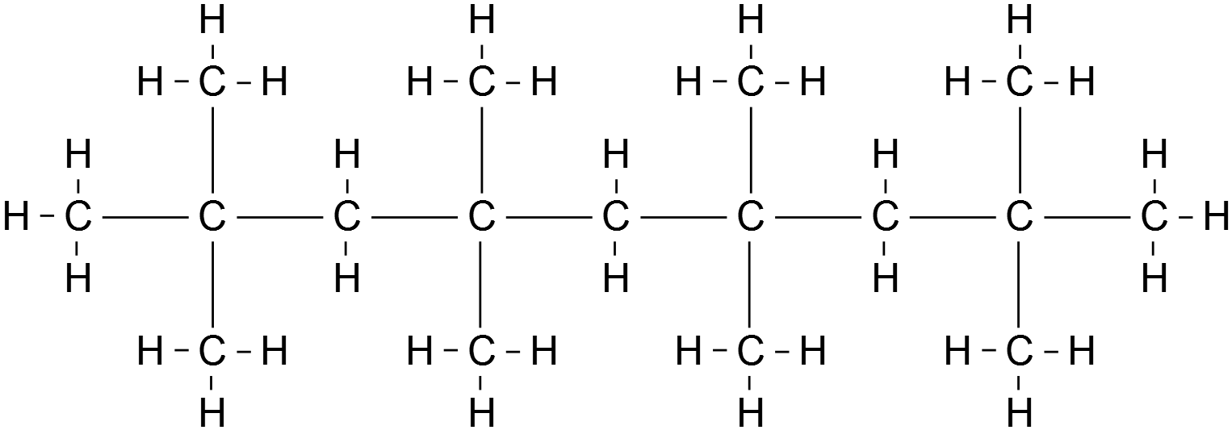
_ _ _ _
_ _ _ _

Which one of the following is the correct name for the monomer used to synthesise this polymer?

(a) but-1-ene
(b) but-2-ene
(c) methylpropene
(d) 2,2-dimethylethene

2. Substance X has an empirical formula of C₂H₄O. Which one of the following could not be substance X?

(a) butanoic acid
(b) ethyl ethanoate
(c) methyl methanoate
(d) methyl propanoate

3. Which one of the following compounds will be readily oxidised to form a carboxylic acid?

- CH₃CH₂C(OH)CH₃
- HOC(CH₃)₃
- CH₃CH₂COOCH₃
- CH₃CH₂CHO

4. Which one of the following pairs of compounds would form methyl propanoate when warmed with concentrated sulfuric acid?

(a) CH₄ and CH₃CH₂COOH
(b) CH₃OH and CH₃CH₂CH₂OH
(c) CH₃OH and CH₃CH₂COOH
(d) HCOOH and CH₃CH₂CH₂OH

5. The two main types of polymerization reactions are addition and condensation. Which of the following polymers results from condensation polymerization?

- Nylon.
- Polythene.
- Polyvinyl chloride.
- Polybutadiene.

6. Which of the following substances would be most soluble in water ?

- CH3CH2OCH2CH3
- CH3CH2CH3
- CHCl3
- CH3CH2OH

7. Consider the molecule below.

Which one of the following will this molecule not react with?

(a) dilute hydrochloric acid
(b) sodium hydrogencarbonate solution
(c) sodium chloride solution
(d) sodium hydroxide solution

8. Which of the following substances is an amine?

(a) CH₃CH₂NO₂
(b) HCOONH₄
(c) CH₃CH₂CH₂CONH₂
(d) CH₃NH₂

9. Which of the following molecules contain(s) no double bond?

1 (CH3)2CHCH3
2 (CH3)3CCHCH2
3 CHCl2(CH2)3COOH
4 (CH3)2CHCHO
5 CH3CH2CHO

(a) 1 only
(b) 3 only
(c) 3 and 4 only
(d) 3, 4 and 5 only

10. Four compounds, W, X, Y and Z are represented below:
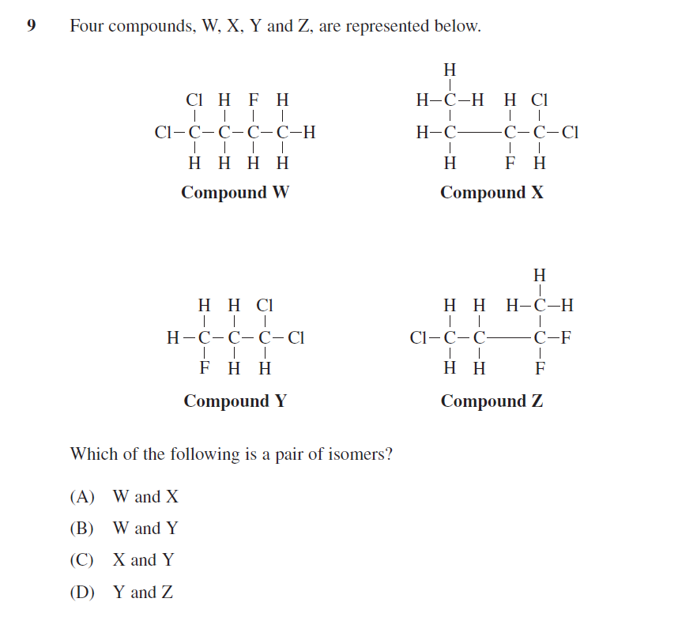

Which of the following is a pair of isomers?

- W and X
- W and Y
- X and Y
- Y and Z

11. Ethanol is removed from the body by reaction with the enzyme alcohol dehydrogenase (ADH). In fact, ADH can oxidise any alcohol. ADH, like all enzymes, is very specific and will not catalyse any other reaction. However, the product of the ADH reaction with an alcohol may undergo further reaction with other enzymes.

The reaction of butan-2-ol with ADH would produce:
- butanal
- butan-2-one
- butanoic acid
- 2-methylpropan-2-one
12. Bromine reacts with both ethane and ethene. A difference in the two reactions is:

- Hydrogen gas is produced with ethane, but not ethene
- Hydrogen bromide gas is produced with ethene but not ethane
- Reaction with ethene occurs only in sunlight
- Reaction with ethane is much slower than ethene

13. Based on the relevant structural formulae of methyl butane and dimethyl propane which of the following is the same for both compounds?

- Molecular structure
(b) Melting point
(c) Solubility
(d) Empirical Formula

14. In a series of experiments the following observations were made about a colourless liquid.

Experiment | Observation
Liquid was added to potassium dichromate solution | No visible reaction
Liquid was added to sodium metal | Colourless, odourless gas evolved, silvery solid dissolved
Liquid was added to ethanol and heated with concentrated sulfuric acid | Fruity smell produced

Which one of the following substances would produce all of these observations?

(a) 2-methylbutan-2-ol
(b) butanoic acid
(c) butan-2-ol
(d) butanone

15. Which of the following statements regarding alcohols is correct?

(a) The -OH functional group on the alcohols makes them basic.
(b) The solubility of alcohols in water increases with increasing length of the hydrocarbon chain.
(c) Primary alcohols are oxidised to acids, secondary alcohols to aldehydes and tertiary alcohols to ketones.
(d) Primary alcohols have higher boiling points than secondary alcohols which have higher boiling points than tertiary alcohols.

Section Two: Short answer (35 marks)

This section has SIX (6) questions. You must answer all questions. Write your answers in the spaces provided

Question 16 [6 marks]
In the table below, draw structural diagrams for the indicated substances:

The organic product from the reaction of ethanoic acid with methanol in the presence H₂SO₄ solution

The cis isomer of
C₄ H₆Cl₂

The organic product formed when sodium metal is added to propan-1-ol

Question 17 (7 marks)

Butan-2-ol can be oxidised with acidified potassium dichromate solution.

(a) Draw the structural formula and name the organic product formed. (2 marks)

Name _____________________________________

(b) (i) Draw and name an isomer of butan-2-ol that will react with potassium dichromate solution to produce a carboxylic acid. (2 marks)

Name _____________________________________

(ii) Write a balanced redox equation for this reaction. (3 marks)

Question 18 (4 marks)
Use your knowledge of the structure and properties of organic materials to explain the following
- Pentan-1-ol boils at a much higher temperature than pentane (2 marks)

____________________________________________________________________
____________________________________________________________________
____________________________________________________________________
____________________________________________________________________
____________________________________________________________________

- Pentan-1-ol is more soluble in water than pentanal. (2 marks)

____________________________________________________________________
____________________________________________________________________
____________________________________________________________________
____________________________________________________________________
____________________________________________________________________

Question 19 (6 marks)
- Complete the table below by giving a brief description and the observations of a chemical test that could be used to distinguish between propan-2-one and propanal. (3 marks)

Description of simple test.

Observations for propan-2-one

Observations for propanal

- A scientist has put propanone into a beaker and propanoic acid into another but did not label the beakers and has forgotten which is which.

Describe one chemical test that could be attempted with each sample that would distinguish between the two liquids.

List the observations relating to the test for both propanone and propanoic acid.
(3 marks)

Description of simple test.

Observations for propanone

Observations for propanoic acid

Question 20 (4 marks)

An organic compound has the molecular formula C₅H₁₂O. Spectroscopic analysis of this compound indicates the presence of a hydroxyl group. The compound reacts slowly with sodium producing hydrogen gas. It does not react with acidified potassium permanganate solution.

- Name the compound and draw its structural formula. (2 marks)

Name:

- Explain how you identified the organic compound (2 marks)

____________________________________________________________________
____________________________________________________________________
____________________________________________________________________
____________________________________________________________________
____________________________________________________________________

Question 21 (8 marks)

- 2-methylpropanal whose formula is (CH₃)₂CHCHO, has two other structural isomers. In the spaces below, draw the structural formula and the IUPAC names of these two isomers. (4 marks)

Structure | IUPAC name

2-methylpropanal can be converted into substance Y by heating it with acidified potassium dichromate

- State an observation that can be made as this reaction proceeds (1 mark)

____________________________________________________________________
____________________________________________________________________

- Name the functional group present in substance Y that us NOT present in 2-methylpropanal (1 mark)

____________________________________________________________________
____________________________________________________________________

- Write a balanced half – equation showing the conversion of 2-methylpropanal into substance Y (2 marks)

____________________________________________________________________
____________________________________________________________________

